1. How an Angular App gets Loaded and Started

* When we launch our angular application via: <http://localhost:4200/> , page gets loaded.
* 4200 is the port where our development server, hosted by the CLI will host our angular application
* To make any changes to the page, we need to make changes in app.component.html, the page gets updated
* Actually app.component.html is not rendered by the server
* Instead only : E:\Expeditors_sample_projects\Angular_Projects\my-first-appmahe\src\index.html is rendered by the server
* We know that angular is a framework which is help to create single page application
* Index.html is the single page
* In app.component.ts file, we can see the selector property which assigns ‘app-root’

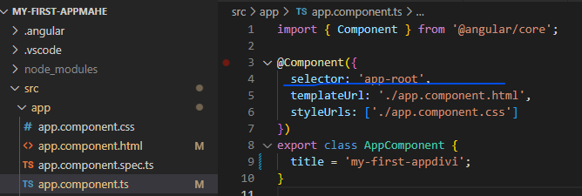

* This is the same text which is specified in index.html

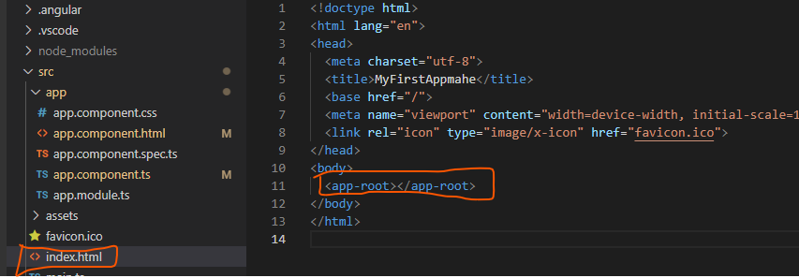

* The template of the component(app-root) specified in index.html is defined in file: app.component.html file .

1. How is Angular Triggered and how is it kicked off to actually run over our body specified in index.html?

* In the final index.html file getting served in the browser, when we inspect source - we see a couple of script imports, which gets injected by the CLI automatically

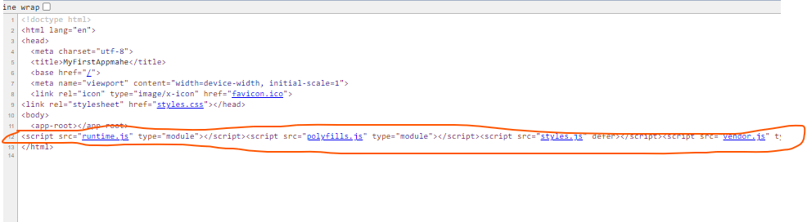

* Hence in the raw index.html we dont see any script imports.

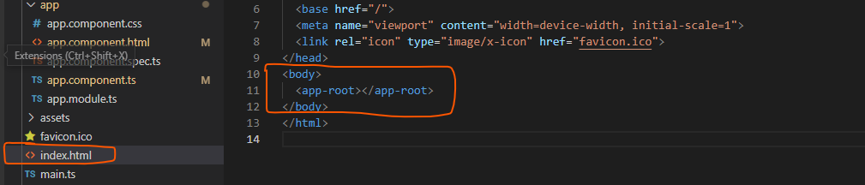

* But whenever ng server process, rebuilds our project, it creates Java script bundles and automatically adds the right imports in the index html file.
* Hence in the final file, we could see the below script imports
* These script files are actually the first code to be executed

**Main.ts**

* Main.ts file is the first file to be executed

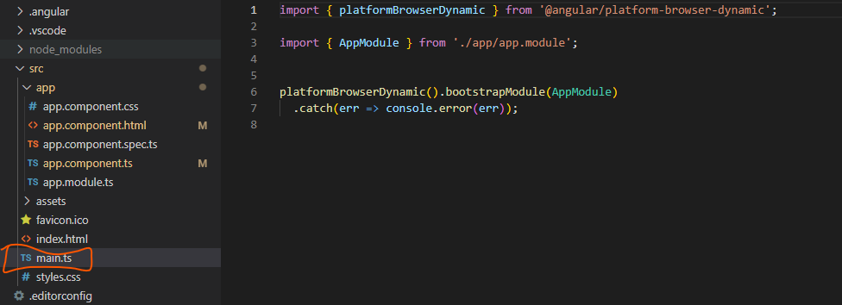

* In this file we do some import

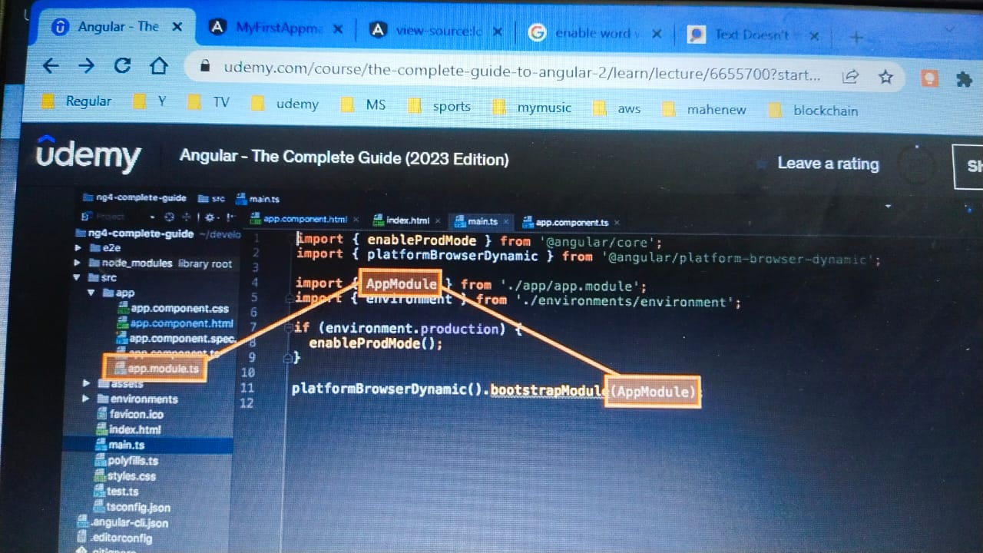

* Then the below line which calls bootstrapModule starts our angular application by passing AppModule to the method



* Now in the app.module.ts file, we see bootstrap array which lists all the components, which should be known to angular, while it analyses our index.html file

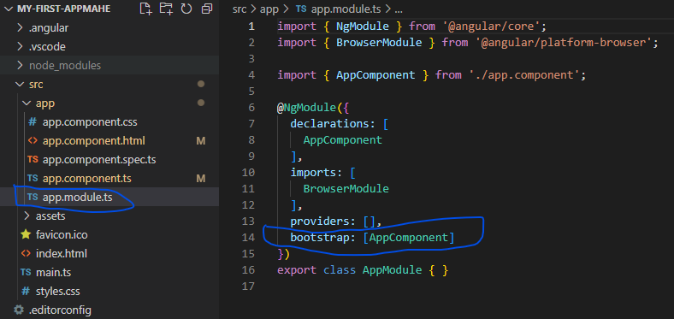

**FLOW SO FAR:**

1. Angular gets started ->
2. Index.html gets loaded first -> then the scripts appended in body section by angular gets loaded and thus main.ts file gets called first
3. main.ts file gets started ->
4. in main.ts we bootstrap an angular application and we pass this module as an argument. ->
5. In this module we tell angular – Hey there is an app component which you should know , when you try to start yourself

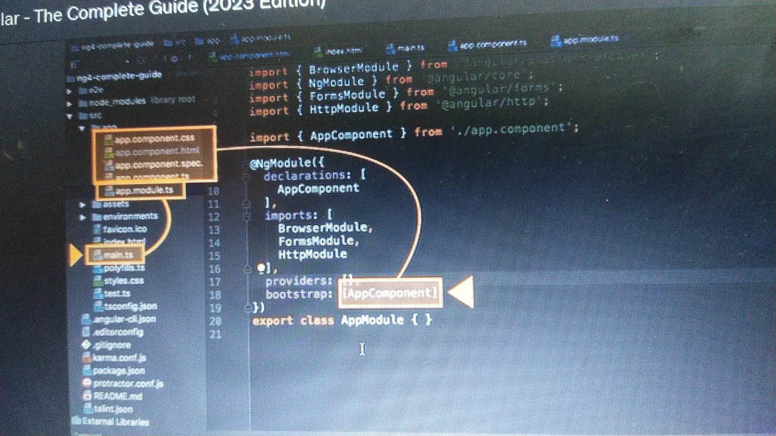

1. Angular now analyses the app component, reads the setup we pass in app.module.ts file, where it knows the selector : app-root in this case



1. Thus by now, angular is able to handle app-root in the index.html, and insert app-component in body section of index.html.
2. Also angular sees for the html file in the app component and loads the same while rendering
3. Thus angular loads the page.

1. Thus Angular is a JS framework, which changes our DOM(‘HTML’) at run time